Student Name: ______Justin Carlson__________________

CS455/655-Mobile Sensor Networks: Homework 1: Total 100 points

**Deadline: September 13, 2021: Submit your HW on Webcampus**

===================================================================================

Write a program (Matlab, Cpp, Python, etc.) to:

1. (25 points) Randomly distribute a network of 100 sensor nodes in the area of 150x150. Assume each sensor node has its interaction range *r =k*d,* where *k* =1.2 and *d* = 14 (See Slide 9 in Lecture 4 to understand these parameters).

Then plot a network of 100 sensor nodes (see an example in figure below)



Answer: I generate random nodes with x/y values from 0-150 and then store them in the adequate lists and then plot them once all 100 of them have been generated

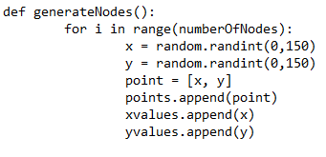

r

1. (25 points) Draw a communication circle of each sensor node based on its interaction range *r*. See the figure below:

Answer:

1. (25 points) Find a number of neighbors for each sensor node and output it on a table. Basically you need to write a programing function to do this job. (See a table in the next page)

Answer: The code checks the distance between all points and if that range is smaller than the max interaction range it gets added as a neighbor to the point.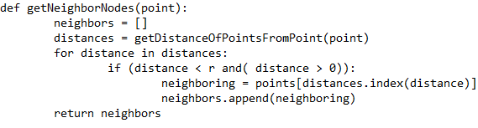

1. (25 points) Link sensor node i with its neighbors by a blue line (if programing on Matlab, use *line* function to do it). Plot the sensor network with linked neighbors. Hint: a sensor network looks similarly to this:



**Answer:** The code checks for every point the distance between that point and all other points on the graph. If the point is within the specified interaction range it will connect the two points with a blue line.

